**How to use Melodia plugin directly from python**

[**https://github.com/justinsalamon/melodia_python_tutorial/blob/master/melodia_python_tutorial.ipynb**](https://github.com/justinsalamon/melodia_python_tutorial/blob/master/melodia_python_tutorial.ipynb)

* **Mac OSX requirements to run Melodia:**

<https://www.upf.edu/web/mtg/melodia>

* + Intel Mac running OSX 10.5 (Leopard) or newer
  + A Vamp host such as [Sonic Visualiser](http://www.sonicvisualiser.org/), [Sonic Annotator](http://www.omras2.org/SonicAnnotator) or [Audacity](http://audacity.sourceforge.net/). Recommended Sonic [Visualiser](http://www.sonicvisualiser.org/) : <https://www.sonicvisualiser.org/>

**To download sonic visualiser in Mac OSX:**

[How to install Sonic Visualiser and a Vamp plugin ...](https://www.youtube.com/watch?v=ojtkaoV0N48)

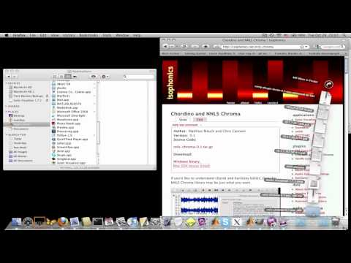

To code for Melodia can be found in the github repo:

**IMPORTANT**

[**https://github.com/justinsalamon/melodia_python_tutorial/blob/master/melodia_python_tutorial.ipynb**](https://github.com/justinsalamon/melodia_python_tutorial/blob/master/melodia_python_tutorial.ipynb)

*Note all these requirements to run the code are for Mac OSX other operating system requirements may vary.*

* + Vamp python module :-

<https://anaconda.org/lparsons/vamp>

*Note to install vamp module* ***gcc*** *module should be installed.*

* + Essentia python module :-

<https://essentia.upf.edu/installing.html#compiling-for-python-3>

* + Melodia

**Tip:** *and easy way to check if the plugin is installed correctly is to open* [*Sonic Visualiser*](http://www.sonicvisualiser.org/) *and then check if the plugin appears in the menu under Transform > Analysis by Category > Pitch > MELODIA - Melody Extraction... (Github)*